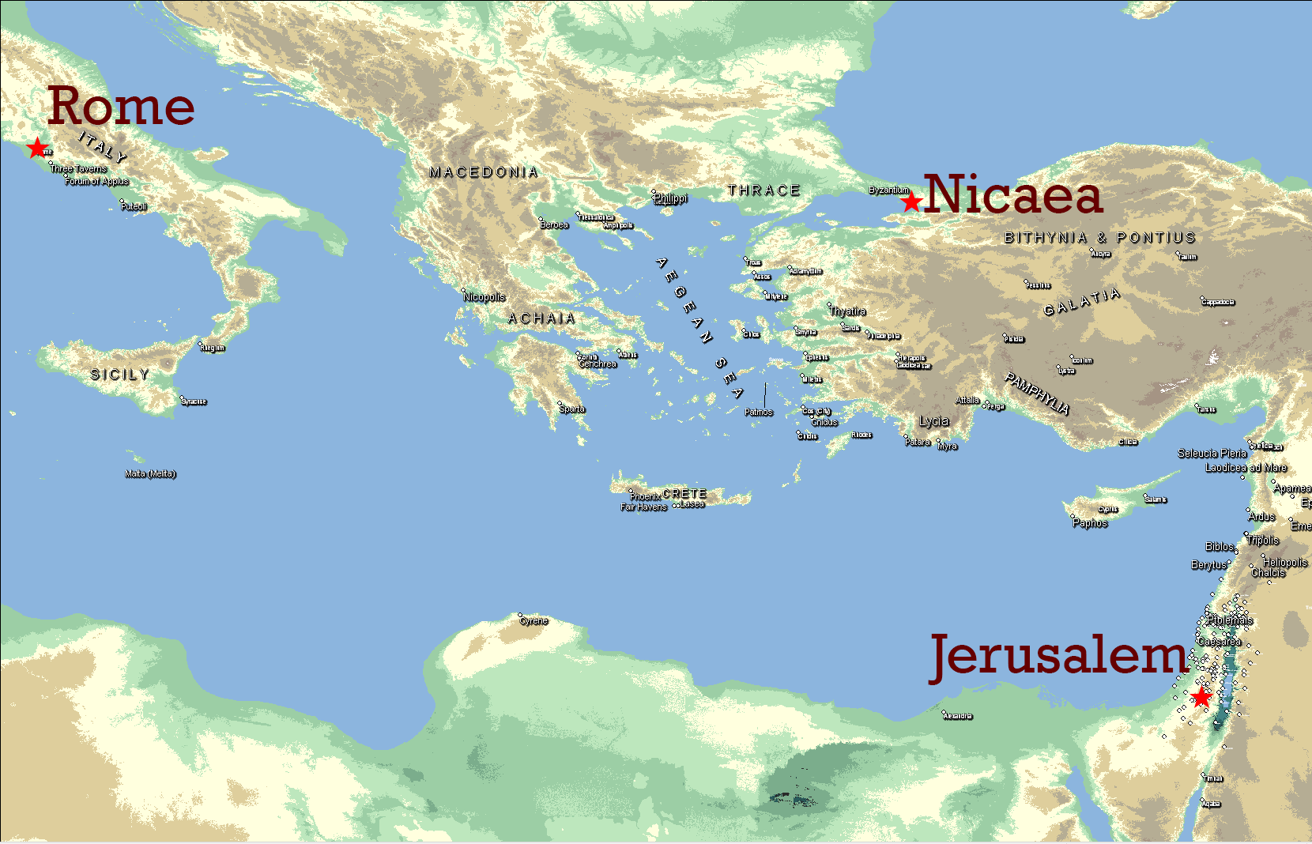
Creeds and Confessions
Creed – Short response to theological need, often meant for use in worship
Confession – Longer response, intended to go in-depth on one or more theological points
Apostles’ Creed
Origin – Baptismal Creed from 2nd Century Rome (Called R by scholars)
Response to heresies:
Marcionism – OT God is not NT God
Docetism – Jesus is not really human; divinity in disguise
Donatism – Those who reject Jesus should never be forgiven
Nicene Creed
Origin – Council of Nicaea, 325 CE
Response to Arian heresy – Christ created by God, not co-eternal with God
Used by Orthodox/East and Catholic/West
9th Century – Western churches added Filioque - Spirit proceeds from Father and the son

Trinity (Doctrine)
Interpretation from Bible, but never found directly stated
“God is three persons sharing one essence”
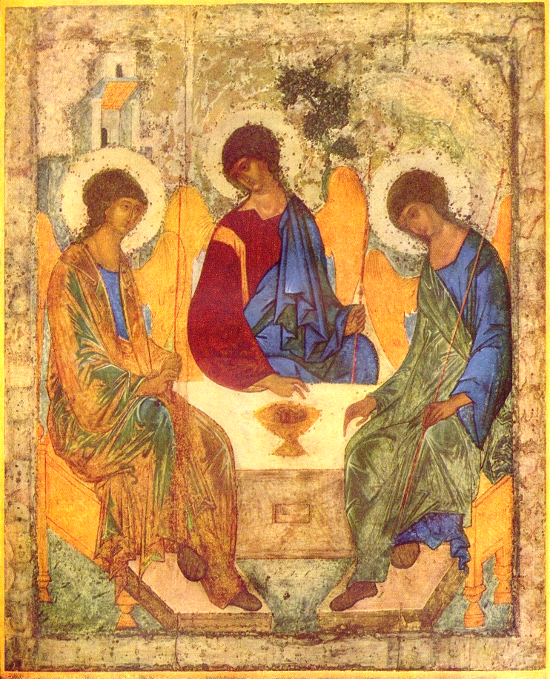
Person = Persona (Mask [Grk])
1 "Icon of the Trinity" by Andrei Rublev
Two Rules of Trinitarian Thinking:
- Works of the Father/Son/Holy Spirit are indivisible
- Perichoresis (Dancing Around [Grk]) – Trinity is one as a divine community who live with and for and in one another in mutual openness, freedom, and self-giving love.
We inevitably emphasize either One at the expense of the Three, or Three at the expense of the One. The Trinity is a mystery to be confessed, not a mathematical problem to be solved.
~Shirley Guthrie, Christian Doctrine

