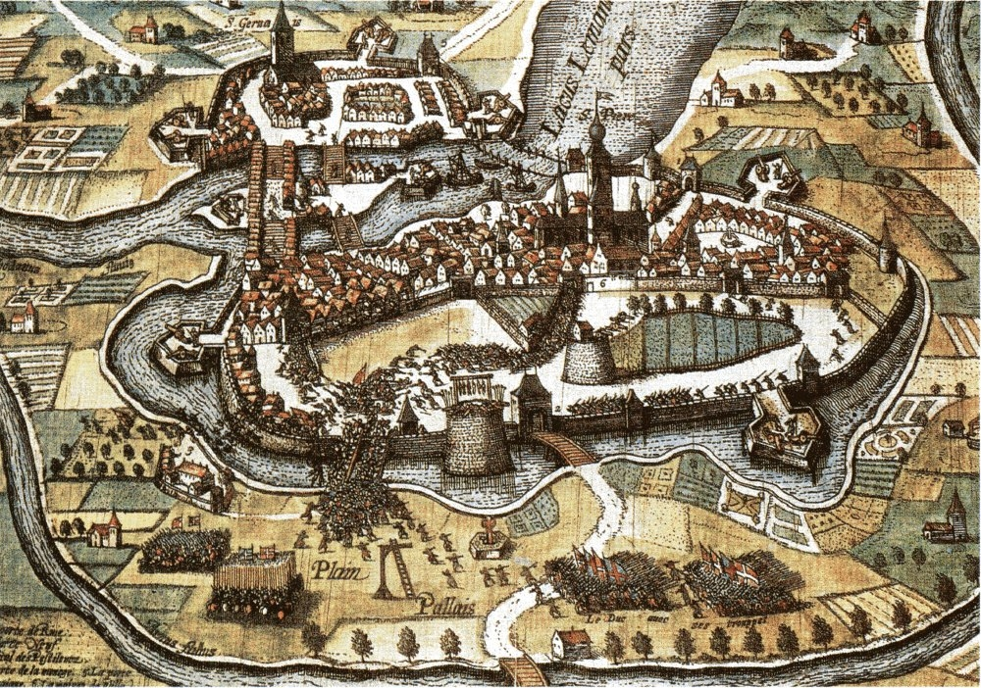
Jehan Cauvin (John Calvin) (1509-1564)
French (Humanist Lawyer, Minister and Reformer)
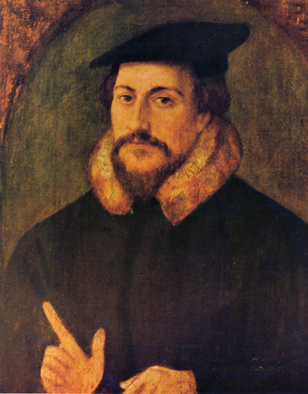
Theological Arguments:
Sum of human wisdom consists of knowledge of God and ourselves
Knowledge of God can only be obtained through scripture
Images of God lead to idolatry (Iconoclasm)
Original sin means humanity needs redemption from Christ
Faith -> repentance -> remission -> regeneration
Justification by faith alone
God has chosen to actively save some people (predestination)
Christ is the head of the universal Church
Reformation of Society as well as Church
Goal: safeguard the rights and freedoms of ordinary people
Favored a combination of democracy and aristocracy
Separation of Powers due to strong force of sin
If rulers rise up against God, they must be put down
Allowed modest interest rates on loans
Everyone must work – it is a means of expressing gratitude to God
John Calvin by Hans Holbein
(c. 1556)
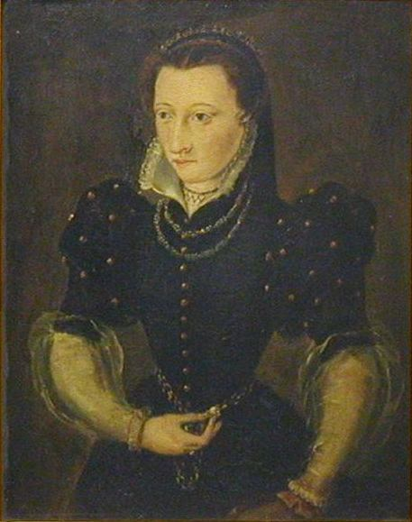
Married Idelette Stoerder de Bure, widowed mother (1540)
Portrait d’Idelette de Bure by Xavier Wuerth (1909)
Second Helvetic Confession (1562)
Written by Heinrich Bullinger as a personal statement of faith
Used in by Frederick III, Elector of the Palatinate as a defense against heresy
Adopted by the Swiss Cantons in 1566, later by Reformed churches in Hungary, France and Poland
More than half about how to live as a Christian
Strong statements supporting infant baptism and rejecting re-baptism
Support for Predestination
Predestination
Augustine of Hippo
God chose from eternity who would come into the Kingdom of God to replace fallen angels and fill up the ranks of the heavenly choir
Only those God chose could turn away from their sins to God, because God would grant them grace
Calvinian
Predestination is a comfort for those who are wracked with worry of their eternal salvation
You don’t have to do anything to earn salvation – it comes from God alone
If God has chosen you, you cannot resist God’s grace
God has a plan for everything in creation
Calvinist
All are not created on equal terms, but some are preordained to eternal life, others to eternal damnation; and, accordingly, as each has been created for one or other of these ends, we say that he has been predestinated to life or death.
~John Calvin, Institutes of Christian Religion, Book III, Chapter 21
Double predestination – God has chosen some for salvation and some for damnation
Presbyterian Controversy
Seen by other denominations as defining doctrine of Presbyterians
Tension between concept of calling/election and human responsibility

